Curriculum Vitae

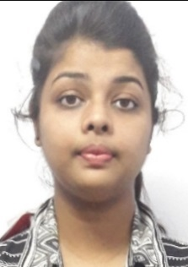

**photograph**  QUREE KUAMRI

Post: Bagodar, Dist: Giridih

Contact no :- 7004917744

[email-myoffice123work@gmail.com](mailto:email-myoffice123work@gmail.com)

**Career Objective**

Looking for a position, Where I can apply my three year of technical learning experience, STEM oriented, technology and curriculum development skill to support company growth and success.

**Academic Qualification**

|  |  |  |  |  |
| --- | --- | --- | --- | --- |
| Course | Board | institution | Passing Year | Marks |
| Higher- Secondary | J.A.C | CHILDREN’S GUIDE ACADEMY, BAGODAR | 2015 | 83% |
| Secondary | C.B.S. E | DAV PUBLIC SCHOOL, RANCHI | 2013 | 89% |
| Graduation | MACKUT | ASANSOL ENGINEERING COLLEGE, ASANSOL | 2020 | Upto-5th semester Avg:8.87 CGPA |

**Communication Languages**

* English (Read, write, speak)
* Hindi (Read, write, speak)

**Technical Skill**

* Language: -Java, Java-Script, C++, C, Python
* Application: -NetBeans, MS-Office
* Operating System: -Windows (7,8,10), Linux
* Algorithm, Data Structure, Discrete mathematics
* DBMS: -Sql

**Personal Skills**

* Fluent and effective communicative skills
* Dynamic Personality
* Adaptive Nature
* Know value of Team work
* Leadership
* Time punctual

**Personal Details**

**Mother’s Name:** Reena Barnwal

**Father’s Name:** Amitabh Barnwal

**Permanent Address:** Near Durga mandir Opposite police station

Bagodar Giridih, Jharkhand, Pin-no:825322

**References:** Available on request

**Citizen Status:**  Indian

**Marital Status:** Unmarried

**Declaration**

The above-mentioned information is true to the best of my knowledge and I bear the responsibility if found otherwise

Date: 30/9/2018

Signature: (Quree Kumari)